**Project Description:**

Tsek is a mobile app designed to help students manage their academic responsibilities. Ideal for college students, Tsek features a progress/deadline tracker, motivational quotes, and a Pomodoro timer. These tools help users stay organized, prioritize tasks, and maintain focus. With a user-friendly interface and essential notifications, Tsek aims to enhance productivity and improve academic performance.

**Requirements Summary**

| **MINIMUM REQUIREMENTS** | Processor Cores | Single Core |
| --- | --- | --- |
| OS | Android 4.4 (KitKat) |
| RAM | 2 GB |
| **RECOMMENDED REQUIREMENTS** | Processor Cores | Quad Core |
| OS | Android 8.0(Oreo) |
| RAM | 4 GB |
| **OTHER REQUIREMENTS** | Permissions | Notifications and Storage |

*Table 1. System Requirements*

To accommodate all users, the minimum requirement is 2 GB of RAM which is sufficient to be used in any device.

**Overview**

We conducted a survey for the Tsek prototype and asked college students to be our participants. It was hosted online on Microsoft Forms. Using a two-part evaluation first has a Likert scale with general evaluation and the second focuses on interactive areas. With that, the objective was to identify the application's general functionality and interactivity to the user.

| **Technique** | **Description** |
| --- | --- |
| Likert scale Evaluation | Likert Scale Evaluation will assess the UX design of the Tsek prototype against industry-standard usability principles. This method provides a structured approach to gauge user perceptions and satisfaction with the app's design, particularly useful for evaluating its effectiveness and user-friendliness under constrained time or resource conditions. |
| Participant Survey and Feedback | After interacting with the Tsek prototype, participants will be given a survey. The survey will include quantitative questions rated on a 5-point Likert Scale and qualitative questions for open-ended feedback. This method ensures unbiased evaluation results, allowing participants to provide structured ratings and detailed insights into their experience with the app's features and usability. |

*Table 2. Evaluation Plan*

The objectives for this prototype are divided into 3 parts: Usability Specifications, Likert scale Evaluation, Participant Survey and Feedback. The user will be asked to access the App Testing Form where they can try the application, thus here are some survey questions prepared, and will be using a 5-point Likert scale to evaluate the prototype:

**SECTION 1:**

**This section will discuss the general user evaluation of the prototype.**

* How would you rate your experience with the Tsek prototype?
* How would you rate the Ul design of the Tsek prototype?
* How easy was it to follow the provided tasks/navigate the Tsek prototype?

**SECTION 2:**

**This section will discuss the overall design, functions, and appearance of each page:**

- Login Page

-Main Menu Page

-Navigation Bar

-Profile Page

-Deadline Page

-Checklist Page

-Pomodoro Page

-Settings Page

**Microsoft Forms Image:**

A survey administration software was used to gather the responses of the users.

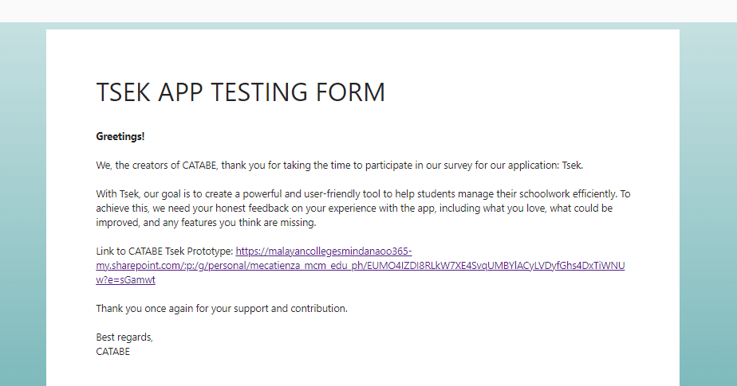

**Tsek App Prototype Message:**

Within the Tsek App Prototype, the testers are greeted with a message that gives them short instructions on how to proceed with the prototype.

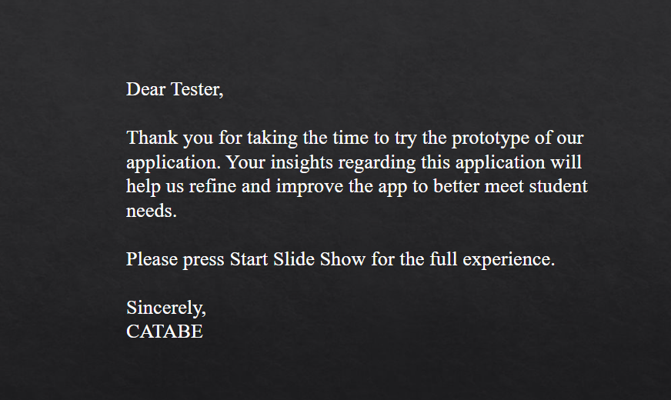

**Data Presentation**

**Data Analysis**

| **SECTION 1** | | | |
| --- | --- | --- | --- |
| Question | Mean | Interpretation | Classification |
| On a scale from 1-5 how would you rate your experience with the Tsek prototype? | 4.40 | Highly Acceptable | Successful |
| On a scale from 1-5 how would you rate the UI design of the Tsek prototype? | 3.80 | Acceptable | Neutral |
| How easy was it to follow the provided tasks/navigate the Tsek prototype? | 4.60 | Highly Acceptable | Successful |
| **SECTION 2** | | | |
| Login Page | 4.00 | Moderately Acceptable | Successful |
| Main Menu Page | 4.00 | Moderately Acceptable | Successful |
| Navigation Bar | 4.20 | Moderately Acceptable | Successful |
| Profile Page | 3.60 | Acceptable | Neutral |
| Deadline Page | 4.60 | Highly Acceptable | Successful |
| Checklist Page | 4.60 | Highly Acceptable | Successful |
| Pomodoro Page | 4.60 | Highly Acceptable | Successful |
| Settings Page | 3.40 | Acceptable | Neutral |

*Table 3. Data Results*

Table 3 shows the results of all the data from the 5-point Likert-scale questions of Section 1 and 2. This data shows that the prototype was mostly smooth in terms of flow and functionality.

**Feedback:**

While the majority of the data shows positive conclusions regarding the app, it still falls short on a few aspects such as the UI of certain pages. Specifically, the Profile and Settings pages. Some users found the UI of both pages too simple or bland, which led to a low score in the survey.

**Design Implications:**

* Does your prototype need to be altered in order to address the results of the analysis, or was it completely successful?
* While the survey shows that the application is successful, there are other parts of the app that still need improvement, such as better UI design.
* What improvements could be made to the design to address any shortcomings?
* In order to address these issues, the best solution would be to overhaul the UI of the Settings and Profile to better clarify its purpose and give better visuals. Another way is to make the visuals more consistent with each other.
* Did you discover any major flaws that would suggest a completely different type of design?
* There were no major flaws present in the design of the app.

**Critique and Summary**

* What were the advantages and disadvantages of your evaluation?
* With the evaluation, we found flaws that we otherwise couldn’t have considered, and we wouldn’t have made these changes based on the users’ experience testing the application. As for disadvantages, due to time constrictions, we were not able to do a proper evaluation with Interviews and had to scrap this idea.
* What would you have done differently knowing what you know now (both designwise and evaluation-wise)? Given more resources, what could you have done that would have produced significantly more insightful evaluation results (again, whether this is an improved prototype or a different evaluation path).
* Knowing what we know now, there are a lot of changes we could apply to the app to make it a lot more effective and visually pleasing. For instance, adding a cloud sync feature (which we had scrapped) and connection to the internet would be very helpful for using multiple devices. Making a PC port would also be useful, and using a better color palette for the app’s UI. If we could dedicate a lot more time and resources for the app, we would apply these criticisms given by the users and improve the app’s functionality.

**Summary of the Project**

The majority of the users shared a common critique regarding the appearance of the profile page and the settings page, for they were too simple or mediocre from what the survey has gathered. Many remarked it lacked an aesthetic appeal. Few also pointed out that the lack of online connectivity and account syncing can cause proper arrangement of completed, outdated tasks to ones from newer unopened or even unfinished tasks.

The survey in conclusion showed a positive result in response from the users, with their experience, rating on the UI design, and how simple and smooth the navigation of the application.